

**Computing Science Assignment 2 on:**

**Flowchart: Converting Hexadecimal   
to Decimal**

**Department of Computer Science Section RCD/2017/D**

**Group 1 Members**

**Name** **ID**

1. Nehimya Mesfin RCD/0620/2017

2. Abigiya Yoseph RCD/0590/2017

3. Dagmawit Hagos RCD/0596/2017

4. Elshaday Abebayew RCD/0597/2017

5. Samrawit Dawit RCD/0625/2017

6. Saron Abenet RCD/0626/2017

7. Sofanit Ashebir RCD/1461/2017

8. Mohamed Zekaria RCD/0615/2017

**Submission Date:** 23rd Feb, 2025

**Submitted To:** Mr. Dagmawi Y.

**Flowchart of Hexadecimal to Decimal Conversion**

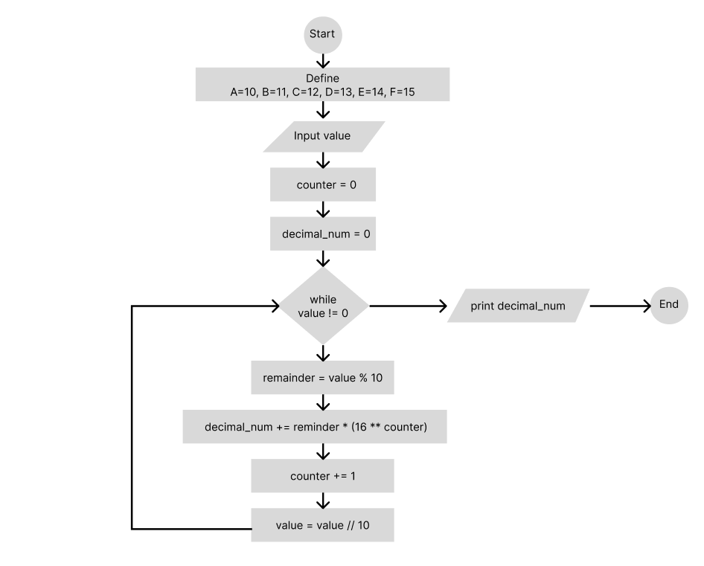

**Explanation of the Flowchart Step by Step:**

1. **Define the values of A, B, C, D, E, F:**
   * Since the user inputs hexadecimal number the alphabetical values must be defined to maintain its flow while working on it.
2. **Enter a value:**
   * A value is input, which is assumed to represent a hexadecimal number in base 16.
3. **Initialize variables:**
   * counter = 0: This variable keeps track of the position of the digit in the hexadecimal number (starting from the least significant digit).
   * decimal_num = 0: This will store the final decimal (base 10) equivalent of the hexadecimal number.
4. **Check if value != 0:**
   * A while loop is used to process the digits of the number until the value becomes 0 (i.e., all digits are processed).
5. **Extract the last digit (remainder):**
   * remainder = value % 10: The last digit of the current value is extracted using the modulus operator (%).
6. **Update the decimal number:**
   * The decimal equivalent of the current hexadecimal digit is calculated and added to decimal_num:

decimal_num += remainder * (16 ** counter)

Here, remainder is multiplied by 16 raised to the power of counter, which corresponds to the positional weight of the digit in hexadecimal format.

1. **Increment the counter:**
   * counter is incremented by 1 to move to the next higher positional digit in the hexadecimal number.
2. **Remove the last digit:**
   * value = value // 10: The last digit of the value is removed using integer division (//).
3. **Repeat:**
   * Steps 4–8 are repeated until value becomes 0.
4. **Output the result:**
   * The final value of decimal_num (decimal equivalent of the hexadecimal number) is printed.

**Example**

**Input:**

Let’s take value = 25 (hexadecimal equivalent of 2 * 16^1 + 5 * 16^0).

**Step-by-Step Execution:**

1. **Initial Values:**
   * value = 25
   * counter = 0
   * decimal_num = 0
2. **First Iteration:**
   * remainder = value % 10 = 25 % 10 = 5
   * decimal_num += remainder * (16 ** counter) = 0 + 5 * (16 ** 0) = 5
   * counter = 0 + 1 = 1
   * value = value // 10 = 25 // 10 = 2
3. **Second Iteration:**
   * remainder = value % 10 = 2 % 10 = 2
   * decimal_num += remainder * (16 ** counter) = 5 + 2 * (16 ** 1) = 5 + 32 = 37
   * counter = 1 + 1 = 2
   * value = value // 10 = 2 // 10 = 0
4. **End Condition:**
   * Since value = 0, the loop ends.
   * Final decimal_num = 37.

**Output:**:

The decimal equivalent of hexadecimal 25 (in numeric representation) is 37.